 Indian School Al Wadi Al Kabir
Assessment – 1
COMPUTER SCIENCE (Code: 083)
SET- I
CLASS : XII Max. Marks:70
Date: Time: 3 hours
General Instructions:
● This question paper contains 37 questions.
● All questions are compulsory. However, internal choices have been provided in some questions. Attempt only one of the choices in such questions
● The paper is divided into 5 Sections- A, B, C, D and E.
● Section A consists of 21 questions (1 to 21). Each question carries 1 Mark.
● Section B consists of 7 questions (22 to 28). Each question carries 2 Marks.
● Section C consists of 3 questions (29 to 31). Each question carries 3 Marks.
● Section D consists of 4 questions (32 to 35). Each question carries 4 Marks.
● Section E consists of 2 questions (36 to 37). Each question carries 5 Marks.
● All programming questions are to be answered using Python Language only.
● In case of MCQ, text of the correct answer should also be written.

 | SECTION A
1. | State True or False:  “Mutable data types in python allows changes at the same memory location”  Ans: True | 1
2. | What will the following expression be evaluated to in Python?  print(6/3 + 4**3//84)  - 4.5  - 2.0  - 4.0  - 2  Ans: B | 1
3. | If a=1,b=2 and c= 3 then which statement will give the output as : 2.0 from the  following:  - >>>a%b%c+1  - >>>a%b%c+1.0  - >>>a%b%c  - >>>a%b%c-1  Ans: B | 1
4. | Which SQL statement is used to display all the data from PRODUCT table in the decreasing order of PRICE?  - SELECT * FROM PRODUCT ORDER PRICE BY DESC;  - SELECT * FROM PRODUCT PRICE ORDER BY DESC;  - SELECT * FROM PRODUCT ORDER BY DESC PRICE;  - SELECT * FROM PRODUCT ORDER BY PRICE DESC;  Ans:D | 1
5. | Assuming that the position of the file pointer is at the beginning of 3rd line in a text file. Which of the following option can be used to read all the remaining lines?  - myfile.read(n-3)  - myfile.read(3)  - myfile.readline()  - myfile.readlines()  Ans: D | 1
6. | Consider the following python code:  F = open('FILE.TXT')  N = F.read(2)  If FILE.TXT contains text as: 12BENGALURU  What will be the data type of N?  - Integer  - Boolean  - String  - None  Ans: C | 1
7. | Which of the following types of table constraints will prevent the entry of duplicate rows?  - Null  - Distinct  - Primary Key  - All the above  Ans: C | 1
8. | Analyze the following code :  tpl1 = (12,42, 35) # Line 1  tpl2 = tpl1 # Line 2  tpl1 += (54) # Line 3  print(tpl1 == tpl2) # Line 4  Identify the line number of code that will result into an error.  - Line 1  - Line 2  - Line 3  - Line 4  Ans: C | 1
9. | Which of the following outcome is expected from the following code:  import random  SIDES = ('EAST','WEST','NORTH','SOUTH')  N = random.randint(1,3)  OUT=""  for x in range (N,1,-1):  OUT=OUT+SIDES[x]  print(OUT)  - SOUTHNORTHWEST  - SOUTHNORTH  - NORTHWEST  - SOUTH  Ans: B | 1
10. | Fill in the blank:  _____________ is a candidate key which is not selected as a primary key.  - Primary Key  - Foreign Key  - Candidate Key  - Alternate Key  Ans: D | 1
11. | Consider the given expression :  53 and not 16= =10 or 19>40  Which of the following will be the correct output if the given expression is evaluated?  - True  - False  - NONE  - NULL  Ans: A | 1
12. | In a table in MYSQL database, an attribute A of datatype char(15) has the value “Malavika”. The attribute B of datatype varchar(15) has value “Tanish”. How many characters are occupied by attribute A and attribute B?  a. 15,6  b. 6,15  c. 8,6  d. 6,8  Ans: A | 1
13. | Which of the following command can be used to open the text file in writing as well as reading mode?  - f=open(“c:\data.txt”,’r’)  - f=open(“c:\data.txt”,’w+’)  - f=open(c:\\data.txt”,’w+)  - f=open(“c:\\data.txt”,’w’)  Ans: B | 1
14. | Which of the following function header is legal?  - def fun(x=1,y)  - def fun(x=1,y,z=2)  - def fun(x=1,y=1,z=2)  - def fun(x=1,y=1,z=2,w)  Ans: C | 1
15. | What will be the output of the following Python Code? ANIMAL={"dog":10,"tiger":5,"elephant":15,"Cow":3}  print("Tiger" not in ANIMAL)  - True  - False  - Error  - None  Ans: A | 1
16. | What is the degree and cardinality of the following relation?  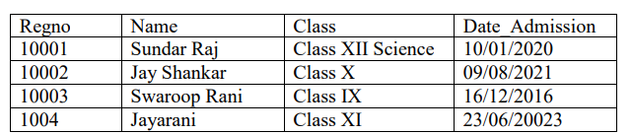  - 4, 5  - 5, 4  - 4, 4  - 4, 5  Ans: C | 1
17 | Given the following dictionaries  dict_exam={"Exam":"AISSCE", "Year":2023}  dict_result={"Total":500, "Pass_Marks":165}  Which statement will merge the contents of both dictionaries?  - dict_exam.update(dict_result)  - dict_exam + dict_result  - dict_exam.add(dict_result)  - dict_exam.merge(dict_result)  Ans:A
18 | Select the correct output of the code:  a = "Year 2024 at all the best"  a = a.split('a')  b = a[0] + "-" + a[1] + "-" + a[3]  print (b)  - Year – 0- at All the best  - Ye-r 2024 -ll the best  - Year – 024- at All the best  - Year – 0- at all the best  Ans:B | 1
19 | What will be the output of the following code?  L = [2, 4, '2', 2.0, [2, 20], 'KV2']  print(L.count(2))  - 1  - 2  - 3  - 4  Ans: B
20 | Assertion (A):- A python function that accepts parameters may be called without any parameters.  Reasoning (R):- Functions can be defined with default values that are used, whenever corresponding values are not received in function call statement.  - Both Assertion (A) and Reason (R) are true and Reason (R) is the correct  explanation of Assertion (A).  - Both Assertion (A) and Reason (R) are true, but Reason (R) is not the correct  explanation of Assertion (A).  - Assertion (A) is true, but Reason (R) is false.  - Assertion (A) is false, but Reason (R) is true.  Ans : D | 1
21 | Assertion(A): read()and readline() are used to read the data from the text file. Reasoning(R): readlines() function is used to read all lines from the file in the form of a List.  - Both Assertion (A) and Reason (R) are true and Reason (R) is the correct  explanation of Assertion (A).  - Both Assertion (A) and Reason (R) are true, but Reason (R) is not the correct  explanation of Assertion (A).  C. Assertion (A) is true, but Reason (R) is false.  D. Assertion (A) is false, but Reason (R) is true.  Ans: B | 1
 | SECTION B
22. | What will be the output of the following code?  def check(L, a=10):  for x in range(1, len(L)):  if L[x]%a == 0:  L[x-1] = L[x]-1  for z in range(0,len(L),2):  print(L[z], ' ' , L[z+1])  check([25, 40, 15, 25], 5)  39 14  24 25 | 2
23. | The code given below accepts a number as an argument and checks whether the given number is perfect number or not. Observe the following code carefully and rewrite it after removing all syntax and logical errors. Underline all the corrections made.  define PerfectNum(num):  sum=0  for i in range(1,num+1):  if n%i==0:  sum=sum+i  if sum==num:  print("Perfect number")  else:  print("Not perfect")  num=input("Enter number:")  PerfectNum(num)  def PerfectNum(num):  sum=0  for i in range(1,num+1):  if num%i==0:  sum=sum+i  if sum==num:  print("Perfect number")  else:  print("Not perfect")  num=int(input("Enter number:"))  PerfectNum(num) | 2
24. | Write a function modifyList(L,n) in Python, which accepts a list L of numbers and n is a numeric value.  Function should:  • Add 5 to all the values divisible by n  • Subtract 5 from all values not divisible by n  • Display the modified list  Example: If L= [ 10,11,13,15,20,2] and n=5 then the function should print [15,6,8,20,25,-3]  def modifyList(L, n):  for i in range(len(L)):  if L[i] % n == 0: # Check if divisible by n  L[i] = L[i] + 5 # Add 5  else:  L[i] = L[i] - 5 # Subtract 5  print(L)  # Example usage  L = [10, 11, 13, 15, 20, 2]  modifyList(L, 5) | 2
25. | Predict the output of the following code :  d={"brand": "Ford", "model": "Mustang", "year": 1964}  str1=""  for i in d:  str1=str1 + str(d[i]) +"@"  str2=str1[ : -1]  print (str2)  Ford@Mustang@1964 | 2
26. | Consider a List L = [10,20,30,[40,50,60],70,80]  Write a single line python statement (using List methods only) to:  - Insert an element 55 as the second last element of the inner list, so that L becomes [10,20,30,[40,50,55,60],70,80]  - ii. Delete the inner list so the L becomes [10,20,30,70,80]  L[3].insert(-1, 55)/ L[3].insert(2,55)  L.remove(L[3])/ L.pop(3)/ del L[3] | 2
27. | Write MySQL statement to create a table named REMEDIAL based on the following specification:  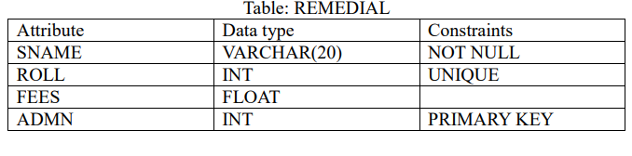  Create table remedial(sname varchar(20) not null, roll int unique, fees float, admn int primary key); | 2
28. | Predict the output of the following code :  data = ['P',20,'R',10,'S',30]  times = 0  alpha = ""  add = 0  for C in range(1,5,2):  times = times + C  alpha = alpha + data[C-1] + '$'  add = add + data[C]  print(times, add, alpha)  1 20 P$  4 30 P$R$ | 2
 | SECTION C
29. | Write a function, test() in Python to read a text file, Story.txt and displays those lines which begin with the word ‘Once’.  OR  Write a method COUNTLINES () in Python to read lines from text file ‘FILE.TXT’ and display the lines which are starting with any vowel.  def test():  f=open(“story.txt","r")  data=f.readlines()  for line in data:  l=line.split()  if l[0]=="Once":  print(line)  f.close()  test()  OR  def countlines():  f=open(" file.txt","r")  lines=f.readlines()  count=0  for w in lines:  if w[0] in "aeiouAEIOU":  print(w)  f.close  countlines() | 3
30. | Consider the table Rent_cab, given below :  Table : Rent_cab  Based on the given table, write SQL queries for the following :  - Add a primary key constraint to a column name Vcode.  Alter table Rent_can add Vcode primary key;  - Increase the charges of all the cabs by 10%.  Update Rent_cab set charges=charges+10/100*charges;  - Delete the column color.  Alter table Rent_cab drop color; | 3
  Vcode | VName | Make | Color | Charges
  101 | Big car | Carus | White | 15
  102 | Small car | Polestar | Silver | 10
  103 | Family car | Windspeed | Black | 20
  104 | Classic | Studio | White | 30
  105 | Luxury | Trona | Red | 9
31. | Consider a Nested List ‘Inventory’ in which all the elements are lists of the format –  [ItemID, ItemName, Price, Quantity].  Write the following user defined functions in python to perform the task specified on the stack named ‘items’ which is initially an empty list.  • Push_item(Inventory) – It takes nested list Inventory as argument and pushes records of those items onto stack which have quantity > 100.  • Pop_items() –It repeatedly pops the top element of stack and displays it.  Appropriate message should be displayed when there are no more elements left in the stack.  For example,  if Inventory = [[101, ‘Pen’, 10, 120],  [102, ‘Pencil’, 10, 100],  [103, ‘Eraser’, 5, 90],  [104, ‘Notebook’, 20, 52],  [105, ‘Marker’, 30, 130],  [106, ‘Sharpener’, 5, 110]]  After execution of Push_Items(Inventory), Stack should contain:  [[101, ‘Pen’, 10, 120], [105, ‘Marker’, 30, 130], [106, ‘Sharpener’, 5, 110]]  The output after Pop_Items() should be:  [106, ‘Sharpener’, 5, 110]  [105, ‘Marker’, 30, 130]  [101, ‘Pen’, 10, 120]  Stack Empty  items = []  def Push_item(Inventory):  for record in Inventory:  if record[3] > 100:  items.append(record)  def Pop_items():  while True:  if items==[]:  print("stack is empty")  break  else:  print(items.pop())  Inventory = [  [101, 'Pen', 10, 120],  [102, 'Pencil', 10, 100],  [103, 'Eraser', 5, 90],  [104, 'Notebook', 20, 52],  [105, 'Marker', 30, 130],  [106, 'Sharpener', 5, 110]  ]  Push_item(Inventory)  Pop_items() | 3
 | SECTION D
32 | Consider the following table HOSPITAL. Answer the questions that follows the table:  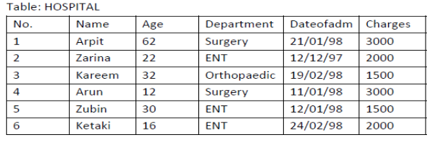  Based on the data given above answer the following questions:  - Write SQL statement to see the structure of the table.  - Write a SQL statement to see the name and age in the descending order of Dateofadm.  - Write SQL statement to display the records where the Name starts with ‘Z’.  - Write SQL statement to display the various departments without repitition.  - DESC Hospital  - Select name and age from hospital order by dateofadmn desc;  - Select * from Hospital where name like ‘Z%’;  - Select distinct department from hospital; | 4
33 | - Differentiate between char and varchar data type in MySQL.  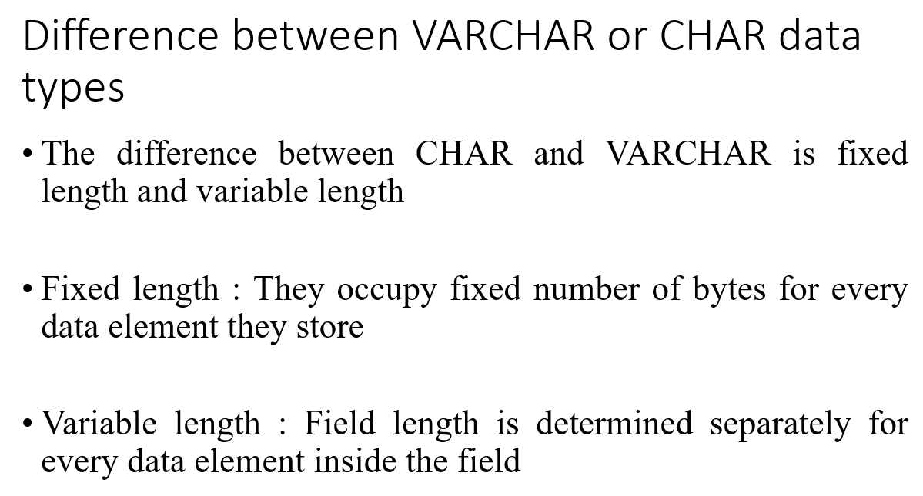  - Consider the table Employees Given below and write SQL queries (a) to (c) based on it.  Table: Employee  Emp_id Name Dob Gender Salary  101 Simar 1994-01-15 F 26000  102 Alok 1995-10-18 M 7000  103 Hasan 1996-08-21 M 25000  104 Kriti 1993-01-12 F 35000  105 Gulab 1994-02-20 M NULL  106 Jaya 1993-12-01 F 16500  - To add the first row of data to the table employee.  Insert into employee values(101,’Simar’,’1994-01-15’,’F’,26000);  - To display the name and gender of employees for whom salary is not given.  Select name,gender from employee where salary is null;  - To delete the records of all employees born before 01 January 1995.  Delete from employee where dob<’1995-01-01’;
34. | A csv file "Happiness.csv" contains the data of a survey. Each record of the file contains the following data:  ● Name of a country  ● Population of the country  ● Sample Size (Number of persons who participated in the survey in that country)  ● Happy (Number of persons who accepted that they were Happy)  For example, a sample record of the file may be: [‘Signiland’, 5673000, 5000, 3426] Write the following Python functions to perform the specified operations on this file:  - Read all the data from the file in the form of a list and display all those records for which the population is more than 5000000.  - Count the number of records in the file.  def show():  import csv  f=open("happiness.csv",'r')  records=csv.reader(f)  for i in records:  if int(i[1])>5000000:  print(i)  f.close()  def Count_records():  import csv  f=open("happiness.csv",'r')  records=csv.reader(f)  count=0  for i in records:  count+=1  print(count)  f.close() | 4
35. | - What is the purpose of seek() and tell() method? Explain with example.  The tell() function returns the current position of the file pointer in the file.  Syntax: <file_object>.tell()  - The seek() function changes the position of file pointer by placing the file pointer at the specified position in the open file.  - Syntax: <file_object>.seek(offset, mode)  - Where offset – number specifying number of bytes  - Mode – 0 for beginning of file, 1 for current position of file pointer and 2 for end of file  - Pawan is a manager working in a recruitment agency. He needs to manage the records of various candidates. For this, he wants the following information of each candidate to be stored: -  Candidate_ID – integer  Candidate_Name – string  Designation – string  Experience – float  He input the data of the candidates and append it in a binary file candidate.dat. Now he wants to write a function update_candidate() to update the data of candidates whose experience is more than 10 years and change their designation to "Senior Manager" so that the changes should be updated to the binary file candidate.dat. Help him to write the function.  import pickle  cd=[]  f=open("candidate.dat","rb+")  try:  while True:  rpos=f.tell()  st=pickle.load(f)  if cd[3]>10:  st[2]='Senior Manager'  f.seek(rpos)  pickle.dump(st,f)  except EOFError:  f.close() | 2+2=4
 | SECTION E
36. | - Explain the difference between primary key and unique constraint in MySQL.  - Consider the table MEMBER given below and write the output of the SQL queries that follow.  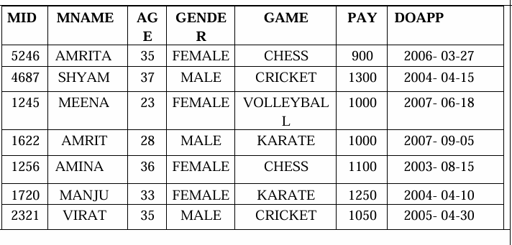  - Display the name, age and pay of female members who receive pay in the range 1000 to 1300.  Select mname, age, pay from member where gender=’female’ and pay between 1000 and 1300;  - Remove the primary key constraint from the column MNAME.  Alter table member drop primary key;  - Display the details of the members whose game is chess & cricket  Select * from members where game in(‘chess’,’cricket’);  - Write the output of the given SQL query. Select MID, MNAME from MEMBER where MNAME like ‘%M%’ and PAY >1000; | 5
37. | Vaibhavi is studying in class 12 and trying to develop a solution for easy record handling of students’ result and performance. She wants to store the following information of the students in the form of a list -  Admission Number - Integer  Name - String  Percentage - float  Her Teacher guided her to use binary files for this purpose and create the following user defined function -  - A Function ADD_Data() to input the data and add it to a Binary file Student.Dat.  - Display( ) - to read all the data from the Binary file and display.  - CountRec( ) - Accepts the range of the percentage(upper bound & lower bound), display the records and count of the records lying in the given range.  import pickle  def ADD_Data():  with open("S.Dat", "ab") as file:  admission_number = int(input("Enter Admission Number: "))  name = input("Enter Name: ")  percentage = float(input("Enter Percentage: "))  student_data = [admission_number, name, percentage]  pickle.dump(student_data, file)  print("Data added successfully!")  def Display():  st=[]  stfile=open("S.Dat","rb")  try:  while True:  st=pickle.load(stfile)  print(st)  except EOFError:  stfile.close()  def CountRec():  lower_bound = float(input("Enter lower bound of percentage: "))  upper_bound = float(input("Enter upper bound of percentage: "))  count = 0  file=open("S.Dat", "rb")  while True:  student_data = pickle.load(file)  if lower_bound <= student_data[2] <= upper_bound:  print(student_data)  count=count+1  print(f"Total records in the given range: {count}")  ADD_Data()  Display()  CountRec() | 5

****************************

